

A Project Report

On

**“MED PAD”**

Batch Details

|  |  |  |
| --- | --- | --- |
| Sl. No. | Roll Number | Student Name |
| 1 | 20211IST0023 | HITESH D |
| 2 | 20211IST0026 | SUSHMITHA V M |
| 3 | 20211IST0020 | SHAMITHA R |

**School of Computer Science,**

**Presidency University, Bengaluru.**

Under the guidance of,

**Dr. Pallavi R**

School of Computer Science,

Presidency University, Bengaluru

**CONTENTS**

1. Introduction aboutProject
2. LiteratureReview
3. Objectives

## Methodology

1. Timeline for Execution ofProject
2. ExpectedOutcomes
3. Conclusion
4. References

**1. INTRODUCTION**

In the pharmaceutical industry, the role of Medical Representatives (MR’s) is critical for driving sales and increasing market share. MR’s are responsible for promoting a company’s pharmaceutical products to healthcare professionals, particularly doctors, with the ultimate goal of influencing prescription decisions. However, despite their pivotal role, many companies face challenges stemming from inefficiencies in the way MRs perform their duties. These inefficiencies often lead to missed opportunities, reduced market penetration, and suboptimal sales figures. Several factors contribute to the underperformance of MR’s. One major issue is the lack of data-driven strategies when deciding where and whom to target. MR’s frequently approach doctors and markets without sufficient insights, leading to wasted effort and minimal returns. Moreover, MRs must carry physical marketing materials such as brochures and product literature, which are cumbersome and inefficient in today's digital age. The absence of a streamlined feedback system for gathering doctor opinions on products further complicates matters, limiting the company's ability to gauge product success and improve its offerings. Another significant challenge is the geographical barrier that prevents MRs from reaching remote locations. In these underserved areas, there is often a high demand for proper medical treatment, but doctors are inaccessible due to logistical constraints. This restricts companies from tapping into regions with unmet medical needs, leaving a void that competitors could potentially fill. Lastly, inadequate monitoring of MRs’ knowledge of the products they promote is a significant concern. Without continuous assessments, it becomes difficult for companies to ensure that their representatives are equipped with the necessary product knowledge to effectively communicate with doctors. Recognizing these inefficiencies, Med Pad has emerged as a revolutionary solution designed to streamline the working process of MR’s. Med Pad combines several advanced features, including a recommendation system powered by machine learning, digital marketing materials, sentiment analysis of doctor reviews, video conferencing for remote communication, and regular product knowledge assessments. With a focus on improving MR efficiency, reaching untapped markets, and ensuring data security, Med Pad presents a transformative platform for the pharmaceutical industry, poised to significantly enhance both MR productivity and company sales.By addressing these challenges head-on, Med Pad not only optimizes the daily workflow of MR’s but also empowers pharmaceutical companies to improve their market penetration and achieve better sales outcomes. Through its innovative and comprehensive feature set, Med Pad represents a key enabler in the pursuit of more efficient, informed, and data-driven pharmaceutical sales operations.

**2. LITERATUREREVIEW**

Artificial intelligence (AI) generally applies to computational technologies that emulate mechanisms assisted by human intelligence, such as thought, deep learning, adaptation, engagement, and sensory understanding[1,2]. This paper will also concentrate on AI strategies for healthcare from the accounting, business, and management perspectives. The authors used the structured literature review (SLR) method for its reliable and replicable research protocol [3]and selected bibliometric variables as sources of investigation. AI technologies can ingest, analyze, and report large volumes of data across different modalities to detect disease and guide clinical decisions. AI applications can deal with the vast amount of data produced in medicine and find new information that would otherwise remain hidden [4, 5]. The cost and time constraints associated with developing newer therapeutic compounds may be a contributing factor in the pharmaceutical industry’s acceptance of AI [6]. he tools and technologies employed by AI are valuable in rapidly identifying hit and lead materials, validating drug targets, and optimizing drug structure design, potentially benefiting the healthcare industry by reducing the cost and timeline associated with discovering novel molecules. However, despite these advantages, AI must still overcome significant data hurdles, including the data’s complexity, growth, diversity, and ambiguity [7, 8]. Deep Learning (DL) and pertinent modelling lessons, to assess the safety and effectiveness of pharmaceutical molecules through extensive data showing and study. DL models beat traditional ML techniques in 15 drugs candidate-related absorption, distribution, metabolism, excretion, and toxicity (ADMET) data sets regarding predictability [9, 10].Management and optimization of inventory systems havebeen the subject of many production planning studies over the years. In the pharmacies, the staff usually lack adequate information about the inventory management systems because their main competency is familiarity with medicines

and having pharmaceutical information. Moreover, an excellent service level is essential to supply the needs of patients for drugs, which is an emergency most of the time [11, 12].Hence, designing an appropriate information system for managing and controlling inventories is more important in pharmacies than other industry sectors [13].Nowadays, smart participation and coordination of inter-organization sections and cross-organization industries in a supply chain have been promoted using the IoS in the Industry 4.0. Such communication entails the suitable design of hardware network and host database as well as communication protocols. By the development of communication services, such as NFC and cloud computing, the organization within the supply chain could communicate better and faster, share required information, decide automatically with less human involvement and extensive data analytics, improve process monitoring performances and, in turn, prevent energy usage, overproduction, and material wastes [14,15].

**3. OBJECTIVES**

* **Exploring AI's impact on healthcare:** The paper aims to evaluate how AI is being applied in the healthcare sector, particularly focusing on clinical decision-making, diagnostics, patient data management, and predictive medicine.
* **Analyzing the scientific research landscape:** The paper conducts a structured literature review to analyze 288 peer-reviewed articles, examining variables such as the most prominent authors, keywords, journals, and geographical contributions to the field.
* **Guiding future research:** The paper aims to identify gaps in existing literature and provide insights for future research in AI applications in healthcare, emphasizing the need for interdisciplinary studies involving data quality management, AI ethics, and medical workforce competencies.
* **Optimization of Drug Formulation**: The paper aims to optimize drug formulation processes using AI technologies, such as Artificial Neural Networks (ANN) and genetic algorithms. These tools help predict optimal drug formulations, taking into account factors like solubility, stability, and bioavailability.
* **Acceleration of Drug Discovery**: Another key objective is to accelerate the drug discovery process by leveraging AI models that can predict drug interactions, toxicity, and effectiveness. This reduces the time and cost associated with traditional drug development.
* **Improvement in Clinical Trials**: The paper also aims to enhance the efficiency and accuracy of clinical trials through AI, by identifying suitable patient populations and adjusting treatments in real-time to optimize outcomes.

**EXPERIMENTAL DETAILS:**

**Software’s used**:

* FRONTEND :HTML, CSS, JavaScript ,React.js
* BACKEND : Node.js , Django (Python)
* MICROSERVICES:Dockers for containerization.
* DATABASE: Mongo DB.
* RESTFUL API: Integration and communication between front end and backend.
* ML RECOMMENDATION SYSTEM: Python for building machine learning models
* VIDEO CONFERENCING :Zoom API

**4. METHODOLOGY**

1. **Requirement Gathering and Analysis:**Conduct in-depth interviews with MRs, sales managers, and stakeholders to identify the specific pain points, challenges, and inefficiencies in the current workflow. Determine key features needed, such as a recommendation system, digital storage, feedback collection, video conferencing, knowledge assessment, and security measures. Analyze existing data (sales figures, MR activities, doctor feedback) to define the scope of the solution.
2. **System Architecture Design:**

* Backend Infrastructure: Design a scalable and cloud-based backend to handle data storage, analysis, and user management. The system should be capable of processing large volumes of sales data for machine learning models, storing marketing materials, and handling user interactions.
* Frontend User Interface (UI): Create an intuitive mobile and web interface for MRs, ensuring ease of navigation. The UI must be responsive and accessible across devices, allowing MRs to interact with the platform on the go.
* Integration with Existing Systems: Ensure compatibility and integration with the pharmaceutical company’s existing CRM systems for seamless data flow and management.

1. **Development of Key Features:**

* Recommendation System: Build a machine learning model that analyzes past sales data, doctor engagement, and prescription trends to recommend target doctors and regions. This system should prioritize untapped areas and optimize MR outreach strategies.
* Digital Repository for Marketing Materials: Develop a secure cloud-based storage system where MRs can access and share marketing brochures, flyers, videos, and other promotional materials during their interactions with doctors.
* Sentiment Analysis Module: Implement a system that collects and processes doctor feedback (through surveys and reviews), applying sentiment analysis algorithms to generate actionable insights regarding product perception.
* Video Conferencing System: Integrate video conferencing tools that allow MRs to communicate with doctors in remote or hard-to-reach locations. This feature should be optimized for low-bandwidth connections to ensure reliability in underserved areas.
* Knowledge Assessment Module: Create a system for periodic knowledge assessments via video conferencing with a central training team. The system should store test results, track progress, and provide learning resources.
* Security and Authentication: Implement security protocols like login authentication to ensure that only authorized personnel can access sensitive data, including marketing materials, sales statistics, and feedback. Encrypt sensitive data both at rest and in transit to prevent unauthorized access or breaches.
* User Experience and Usability Testing: Conduct usability testing with MRs to ensure that the platform is intuitive and meets their practical needs. Address any feedback to enhance the user experience. Refine the design to reduce friction and ensure that features are easily accessible, especially in time-sensitive environments like MR visits.
* Deployment and Integration: Deploy the solution across the pharmaceutical company’s MR teams, ensuring proper integration with existing infrastructure. Provide training and support to MRs on how to use Med Pad’s features effectively, including the recommendation system, digital marketing material access, and feedback collection tools.

This design procedure ensures that Med Pad is user-friendly, efficient, and scalable effectively addressing the inefficiencies of Medical Representatives while driving higher sales and better market penetration for pharmaceutical companies.

**5. OUTCOMES**

1. Improved Efficiency of MR’s: MR’s are able to target doctors and regions more effectively using the recommendation system, which prioritizes areas with high potential based on historical data. This leads to more focused and productive visits, reducing wasted efforts and time.
2. Enhanced Sales and Market Penetration:By guiding MRs to untapped or “virgin” areas, MedPad helps pharmaceutical companies access new markets and increase the number of prescriptions, ultimately improving sales figures. The platform aids in better market penetration by reaching underserved regions where competitors have not yet established a presence.
3. Seamless Access to Marketing Materials:The digital repository feature allows MRs to carry and share marketing materials, like brochures and flyers, directly from their mobile devices. This reduces their physical burden and ensures they always have access to the latest materials, leading to more professional and efficient interactions with doctors.
4. Data-Driven Feedback and Product Improvement:The sentiment analysis feature, which analyzes feedback from doctors about pharmaceutical products, helps companies gain insights into how their products are being received in the market. This data enables timely improvements to product offerings and marketing strategies, ultimately driving better doctor engagement and prescription rates.
5. Increased Reach through Remote Access:The video conferencing feature allows MRs to connect with doctors in remote or hard-to-reach areas. This removes geographical barriers and opens up new opportunities to serve populations that otherwise may not have had access to the company’s products. It also helps establish relationships in regions that have been previously inaccessible.
6. Continuous Knowledge Enhancement:The platform’s knowledge assessment feature ensures that MRs is regularly tested on their product knowledge through periodic evaluations. This ensures that they are always equipped with accurate and up-to-date information, leading to more informed and persuasive interactions with healthcare professionals.
7. Improved Security and Data Integrity:The inclusion of advanced security measures such as fingerprint authentication protects sensitive company data, including sales figures, marketing materials, and doctor feedback. This builds trust among users and ensures that data is only accessible to authorized personnel.
8. Scalability and Reliability:MedPad’s cloud-based design allows it to scale as the pharmaceutical company grows, accommodating an increasing number of MRs, doctors, and sales activities. The platform’s reliable infrastructure ensures that features like video conferencing and data access perform seamlessly, even under heavy use.
9. Higher Productivity and Better Results:Overall, MedPad empowers MRs to work more efficiently, make data-driven decisions, and improve their performance. With optimized targeting, continuous knowledge improvement, and easier access to materials, MRs can achieve better results in terms of both prescriptions and sales growth.

**6. TIMELINEOF THE PROJECT/PROJECTEXECUTION PLAN**

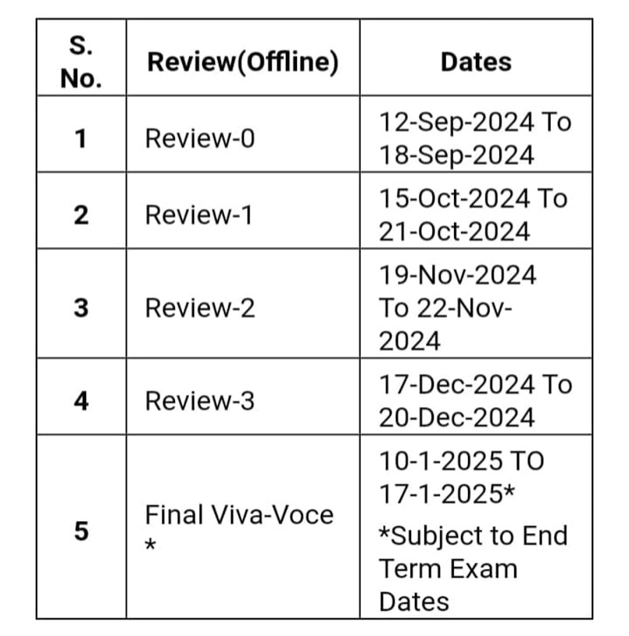

**7. CONCLUSION**

The pharmaceutical industry is highly competitive, and companies rely heavily on their Medical Representatives (MRs) to drive sales and market penetration. However, the inefficiencies in the current working processes of MRs, such as poor targeting, manual handling of marketing materials, limited feedback mechanisms, geographical barriers, and inconsistent product knowledge, contribute to poor sales outcomes. Recognizing the critical role of MRs in achieving business success, Med Pad offers a comprehensive solution designed to revolutionize the way MRs operate, thereby improving their effectiveness and boosting company performance.

Med Pad addresses these inefficiencies through a set of advanced and innovative features. Its machine learning-based recommendation system helps MRs optimize their outreach by targeting high-potential doctors and regions based on historical sales data.Another key advantage of Med Pad is its digital repository for marketing materials, which replaces the outdated practice of carrying physical brochures and flyers.The sentiment analysis module incorporated into Med Pad further enhances its value by providing pharmaceutical companies with actionable insights into how doctors perceive their products.Med Pad's video conferencing feature addresses one of the most significant challenges faced by MRs: reaching doctors in remote or inaccessible locations. Through this feature, MRs can engage with healthcare professionals in underserved regions, ensuring that people in those areas receive proper medication and medical advice.Med Pad’s emphasis on security and scalability ensures that the platform is both reliable and capable of handling the growing demands of the pharmaceutical industry.

In conclusion, Med Pad represents a significant leap forward in optimizing the efficiency of Medical Representatives in the pharmaceutical industry. By integrating data-driven decision-making, digital tools, feedback analysis, remote engagement, continuous learning, and robust security, Med Pad transforms the way MRs work, making them more productive and effective. For pharmaceutical companies, this leads to better market penetration, increased sales, and a competitive edge in the industry. Ultimately, Med Pad helps MRs maximize their potential, making them valuable assets in achieving the company’s sales and growth objectives.

**REFERENCES**

1. Tagliaferri SD, Angelova M, Zhao X, Owen PJ, Miller CT, Wilkin T, et al. Artificial intelligence to improve back pain outcomes and lessons learnt from clinical classification approaches: three systematic reviews. NPJ Digit Med. 2020; 3(1):1–16.
2. Tran BX, Vu GT, Ha GH, Vuong Q-H, Ho M-T, Vuong T-T, et al. Global evolution of research in artificial intelligence in health and medicine: a bibliometric study. J Clin Med. 2019; 8(3):360.
3. Massaro M, Dumay J, Guthrie J. On the shoulders of giants: undertaking a structured literature review in accounting. Account Auditing Account J. 2016; 29(5):767–801.
4. Hamid S. The opportunities and risks of artificial intelligence in medicine

And healthcare [Internet]. 2016 [cited 2020 May 29]. http://www.cuspe.

org/wp-content/uploads/2016/09/Hamid_2016.pdf.

1. Massaro M, Dumay J, Guthrie J. On the shoulders of giants: undertaking a

structured literature review in accounting. Account Auditing Account J.

2016; 29(5):767–801.

1. Waring MJ, Arrowsmith J, Leach AR et al (2015) An analysis of the attrition of drug candidates from four major pharmaceutical companies. Nat Rev Drug Discov 14:475–486. <https://doi.org/10.1038/nrd4609>.
2. Martin L, Hutchens M, Hawkins C, Radnov A (2017) How much do clinical trials cost? Nat Rev Drug Discov 16:381–382. https://doi.org/10. 1038/nrd.2017.70.
3. Mak K-K, Pichika MR (2019) Artificial intelligence in drug development:

present status and future prospects. Drug Discov Today 24:773–780.https://doi.org/10.1016/j.drudis.2018.11.014.

1. Zhang y, Zhang G, Shang Q (2017) Computer-aided clinical trial recruitment based on domain-specific language translation: a case study of retinopathy of prematurity. J Healthc Eng 2017:1–9. <https://doi.org/10.1155/2017/7862672>.
2. Zhu H (2020) Big data and artificial intelligence modeling for drug discovery. Annu Rev PharmacolToxicol 60:573–589. https://doi.org/10. 1146/annurev-pharmtox.
3. Kelle, P., J. Woosley, and H. Schneider, Pharmaceutical supply chain specifics and inventory solutions for a hospital case. Operations Research for Health Care, 2012. 1(2-3): p. 54-63.
4. Uthayakumar, R. and S. Priyan, Pharmaceutical supply chain and inventory management strategies: Optimization for a pharmaceutical company and a hospital. Operations Research for Health Care, 2013. 2(3): p. 52-64.
5. Chen, Y.-T. and H.-Y. Chang, Improve the management of pharmaceutical inventory by using an IoT based information system. Int J Soc Sci Humanit, 2017. 7(8): p. 569-573.
6. Wang, G., et al., big data analytics in logistics and supply chain management: Certain investigations for research and applications. International Journal of Production Economics, 2016. 176: p. 98-110.
7. Waibel, M., et al., Investigating the effects of smart production systems on sustainability elements. Procedia Manufacturing, 2017. 8: p. 731-737.